District Councillors Report to Hasketon Parish Council
For March 2022
Carlford and Fynn Valley Ward.
Rushmere Village, Great Bealings, Little Bealings, Playford, Bredfield, Grundisburgh & Culpho,
Witnesham and Swilland, Westerfield, Hasketon, Clopton, Charsfield, Dallinghoo, Tuddenham, Boulge, Burgh, Debach, Otley.

From District Councillor
Cllr Colin Hedgley
Millions of pounds of investments approved for projects across East Suffolk
Investment worth over £339 million has been approved for projects across the district.  As part of our budget setting process, a programme of capital expenditure, including a General Fund Capital Programme and Housing Revenue Account (HRA) Capital Programme, has been agreed. | 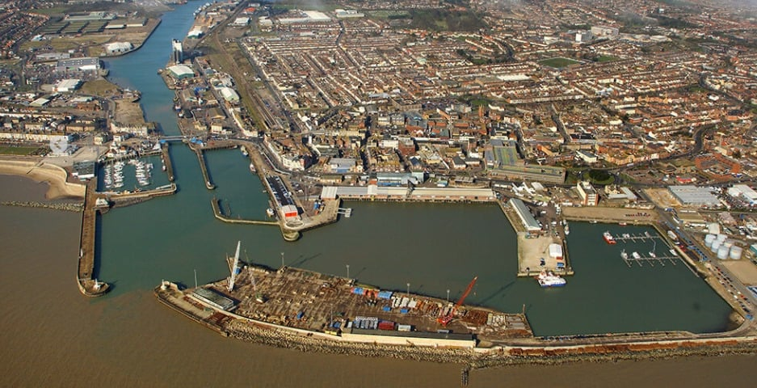

Within the programme, over £118m has been allocated for planning and coastal management projects over the next four years, with a further £36.86m for economic development and regeneration schemes.
Some of the major projects to receive investment within this period include:
• £96m for permanent flood defences to protect homes and businesses in Lowestoft
• £50m for the Felixstowe North Garden Neighbourhood Regeneration Project, including a total of £44m to provide a new leisure centre and associated infrastructure
• £14.2m for the enhancement of Southwold Harbour and Caravan Park (subject to external funding)
• £6.4m on creating start up units for local businesses in Lowestoft
• £5.75m for the development of the South Seafront area and Martello Café, in Felixstowe
• £3.3m for Thorpeness flood defences (subject to external funding)
• £0.69m for Thorpeness emergency flood defence works
Projects already allocated funding from this year's budget include the replacement of beach huts in Lowestoft (£1m), the purchase of land to extend cemetery provision across the district (£395,000) and the development of sports hubs in Felixstowe (£197,000).

Levelling Up White Paper announcement
The first nine areas to be invited to agree new county deals have been announced as part of the Government’s Levelling Up White Paper.
The areas invited to begin negotiations will be Cornwall, Derbyshire and Derby, Devon, Plymouth and Torbay, Durham, Hull and East Yorkshire, Leicestershire, Norfolk, Nottinghamshire and Nottingham, and Suffolk.
It is really pleasing that Suffolk is one of the nine areas to be chosen for a county deal. It offers significant possibilities in terms of addressing regional inequalities, maximising resources and ensuring greater accountability, here in Suffolk, for powers previously held in Westminster.
Naturally, we are committed to ensuring that any deal benefits East Suffolk and its residents, and we're now looking forward to further discussions with our partners and the Government to consider how a county deal can work for our communities. It’s important that any deal contains a policy and funding mix which can make a real difference, and we eagerly await the full details of the White Paper.

Closure of second homes tax loophole
We welcomed the announcement that a loophole which allowed some second home owners to avoid paying either council tax or business rates is to be closed.
The announcement comes as a result of a two-year campaign following an article in The Times which exposed the loophole of second home owners being able to register for business rates, then claiming relief by stating that their properties were available for let for 140 days each year but without actually having to let them.
Under tough new measures, effective from April 2023, those second home owners will have to prove that their holiday lets are being rented out for a minimum of 70 days each year in order to access small business rates relief, where they meet the criteria.
Holiday let owners will have to provide evidence such as the website or brochure used to advertise the property, letting details and receipts.
Properties will also have to be available to be rented out for 140 days per year to qualify for the relief.

Youth Voice is back!
A scheme dedicated to involving young people in local issues which affect them is back and we want as many youngsters as possible to get involved and help make a real difference.

Youth Voice was designed to make it easier than ever for young people to share their thoughts and to see how these opinions can help shape their communities.

A new website has been created with a simple form
for young people to have their say and it will also be widely promoted in schools and via social media – including a dedicated Instagram account. This will be alongside Youth Voice ‘collection boxes’ which have previously been placed in a variety of locations and used successfully to develop new ideas.

Any information which is provided is then shared with organisations and key decision makers who can help address the issues raised and help make a real difference, such as local councillors, East Suffolk Community Partnerships, Suffolk Police and other key partners.

Anyone aged between 11 and 24, can share their thoughts online quickly and easily by filling out a short form at https://my.eastsuffolk.gov.uk/service/Youth_voice

Youth Voice is also on Instagram now so young people can see how their feedback is helping to make real changes in local communities by following ‘eastsuffolkyouthvoice’.

The Communities Team is currently contacting sites, such as schools and youth clubs, which had ‘Youth Voice collection boxes’ installed prior to the pandemic to encourage them to reinstall these as the service relaunches.

Landmark building completed on Felixstowe’s South Seafront
As part of ongoing investment in Felixstowe’s South Seafront, the development of a new iconic building has now been completed, bringing a new exciting resort experience one step closer.

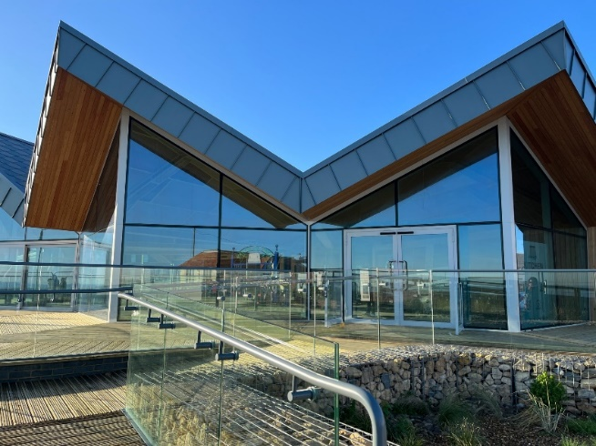 | The building will house a new café named ‘The Kitchen @ Felixstowe’, run by our operational partners, The Kitchen @ Group, who are currently carrying out the internal fit out which will include a bakery counter, contemporary brasserie type menu and unrivalled sea views.  Once completed, the café will play a key role in helping the town as it continues recovering from the impact of Covid-19,
attracting local people and visitors alike by offering indoor and outdoor dining with unspoilt views of the seafront. This will not only support tourism, but it will also help the economy by offering local employment opportunities, making the South Seafront an exciting place to visit, live, work and invest.

Interactive tool allows public to monitor progress on delivering Local Plans
An interactive online feature has been launched for the public to track progress on the implementation of the Suffolk Coastal and Waveney Local Plans.
It includes a range of monitoring data covering housing, economy, retails, natural environments and many more topics and can be accessed at https://storymaps.arcgis.com/stories/dfbbb431cf6c44c88bc58975e59ce191

Work begins on demountable flood gate
Construction has begun on a demountable flood gate on the South Pier in Lowestoft as part of wider flood defence work, which will see the construction of glass floodwalls around the Royal Norfolk and Suffolk Yacht Club and the South Pier.
Having started on Monday 17 January 2022, construction will continue until March. Following a summer break to prevent disruption during the busy tourist season, work will then recommence in October 2022. The walls are due to be completed in spring 2023.

Post Office conservation repairs has begun
Conservation repairs to the façade of the Grade II listed former Post Office on London Road North in Lowestoft, carried out as part of the Lowestoft Heritage Action Zones project, started on Monday 17 January 2022.  It was built as a central post office for the town and served to combine several of the more provincial post offices which existed across the town prior to the 1880s. | 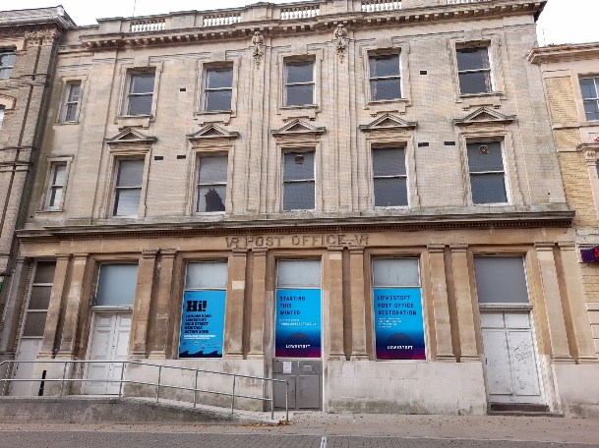
Planning and listed building consent has been approved for works to fix the roof, repair the windows, carry out conservation of stonework on the façade and reconfigure the ground floor windows to restore the entrance to the central bay of the building, as per the original design. This will incorporate repositioning the existing ramp which would greatly improve the appearance of the building.

These repairs will be funded through the London Road, Lowestoft High Street Heritage Action Zone, financed by Historic England and East Suffolk Council, delivered in partnership with Lowestoft Town Council and East Suffolk Building Preservation Trust.

Three fined for breaching planning enforcement notice
Three people have been sentenced after pleading guilty to breaching an enforcement notice issued by the Council.
The enforcement notice related to the change of use of land, without planning permission, at Bridge Farm, Top Street, Martlesham, from a mixed use for agriculture and storage of cars and containers, to the storage of vehicles, containers, caravans, trailers, boats, digger buckets, lorry backs, bricks, building materials, pallets, wall insulation, scrap metal, metal drums, lorry trailers, rubbish, tyres, and other miscellaneous items not associated with agriculture.
Two of the defendants were each fined £2,000 and ordered to pay £1,500 in costs and a court surcharge of £190, while the third was fined £1,000 and ordered to pay £855 costs and a £100 court surcharge.
Read the full release with all the details at www.eastsuffolk.gov.uk/news/three-fined-for-breaching-planning-enforcement-notice/

Funding
Some very worthwhile projects have received funding from your local councillors Colin Hedgley and Tony Fryatt this financial year:

- Singing Ducklings £475. (CH &TF)
- Womens Refuge £2000. (CH & TF
- Grundisburgh Playing Field £2000 (CH & TF)
- Grundisburgh New village Hall Solar Panels £1000 (CH)
- Angela Cobbold Hall Little Bealings £400 (CH)
- Rushmere Village Hall £2000 (CH)
- Bealings village hall £900 (CH)
- Grundisburgh School Verge Safety £1000 (CH)
- Riding for the Disabled £1000 (TF)
- Swilland &Witnesham Play equipment £1000 (TF)
Recycling- Some questions and answers
How is your recycling dealt with?
(Press Cntrl then left click, in order to follow the link)
- https://www.suffolkrecycling.org.uk/learning-zone/where-recycling-goes
What Happens to the Content of my Recycling Bin?
- When we recycle our household waste in East Suffolk this is only start of the process .
- Many people ask – what happens to my recyclable materials? Upon collection, waste from our blue bin is taken to the Materials Recycling Facility (MRF) at Great Blakenham, operated by Biffa, where it is sorted and packed.
- For metals, 3,278 tonnes were recycled in the UK and 313 in Germany.
- For cardboard the result is more varied: only 389 tonnes were recycled in the UK, while 5,729 tonnes were sent to (in descending order) Turkey, Taiwan, India, China, Vietnam and Thailand. For paper, similarly, 5,770 tonnes were recycled in the UK while 16,427 tonnes went to India, China, Malaysia, Indonesia, Thailand and Vietnam.
- For plastics, 6,059 tonnes were recycled in the UK while Turkey and Romania took most of the remaining 2,000 tonnes.
- Figures are for last year (2020/21).
- This of course begs the question, why are we exporting so much and not recycling our own materials here? Is it because we do not have the industries in the uk that use these materials . And this leads us to the bigger issue of how all our decisions are interlinked to the world and yes decision we make locally can have an impact in some far away county . These are global markets . Just think for a moment where most of our consumer goods are produced , in fact just look at where food is produced .

- Another question often asked is, how much of the material collected is used? Contaminants such as general rubbish, food, glass, cartons, textiles and even used nappies need either to be removed by hand, an unpleasant and potentially dangerous job, or sometimes the whole load has to be rejected. In 2020/21 13,000 tonnes of wrong material were put in Suffolk's household recycling bins, resulting in a contamination rate of 25%. This is bad for the environment and costly for taxpayers.
- Residents ask why glass isn’t allowed in the blue recycling bin. Glass is the best item to recycle. Often when we talk about recycling items are just downgraded into their component parts. However glass is recycled into glass. – and this cycle can be never ending . However to achieve this we need a completely separate stream of collection , hence the bottle banks . So when we take glass to these banks we really are doing something important to help the environment .
- Questions on what can and can be placed in the blue bin or how to dispose of different items – big or small can be found at : https://www.suffolkrecycling.org.uk/a-z-of-recycling
- The environment bill was passed last year by Westminster and this year long awaited secondary legislation will be passed allowing substantial changes in how waste will be collected . Residents may be asked to have different bins and manage waste in new ways, and I will explain more about this when we know more.
- But for now we should think about reduce , reuse and recycle .
- And just pause and think about what we are putting into the blue bin .

Chance to run the runway as charity event returns to MOD Woodbridge
A charity fun run is set to return to a military base near Woodbridge next month in support of the armed forces community, past and present. The third Honour Run, organised by East Suffolk Council and the Suffolk branch of the Royal British Legion (RBL), will set off from Rock Barracks on Sunday, March 13. New for 2022 will be a half marathon distance, along with the established 5km and 10km runs, which people can choose to walk, jog, or run to raise funding for the Poppy Appeal. This is a unique opportunity to run within MOD Woodbridge, and with some of the route on the historic runway, it’s one not to miss.
In previous years, Honour Run participants helped to support former and current service personnel by raising more than £3,500 for the appeal. With East Suffolk Council committed to promoting physical and mental well-being, the Honour Run provides a great opportunity for people to take part in an organised sporting event for a good cause.
Rock Barracks is home to soldiers whose regiment provides engineer support to two Royal Engineers Regiment and was granted the Freedom of Woodbridge in 2006.
Anyone who would like to help out, without taking part, can volunteer to assist with the running of the event by emailing activecommunities.scdc@eastsuffolk.gov.uk or calling 01394 444652. For more information and to sign up, visit the running page of the East Suffolk Council website.
Your District Councillors are:-
Colin Hedgley (Colin.Hedgley@eastsuffolk.gov.uk)
Tony Fryatt (Tony.Fryatt@eastsuffolk.gov.uk)

