District councillors Report to Hasketon Parish Council for November 2021
Carlford and Fynn Valley Ward.

Rushmere Village, Great Bealings, Little Bealings, Playford, Bredfield, Grundisburgh & Culpho, Witnesham and Swilland, Westerfield, Hasketon, Clopton, Charsfield, Dallinghoo, Tuddenham, Boulge, Burgh, Debach, Otley.

From Cllr Colin Hedgley

The Environment is at the top of everyone’s agenda at present so I thought I would reprint something I published here some time ago just to remind ourselves of some of the things that our council has already set out and agreed.

Our climate commitment At its Full Council meeting on Wednesday 24 July 2019, East Suffolk Council voted unanimously to step up its positive work on environmental issues to help fight climate change.It has joined other local authorities in recognising the fact that there is a climate emergency and committed itself to doing more to reduce its own carbon emissions and to encourage communities to help fight climate change.

What next?
- The council commissioned an independent review of its progress to-date identifying opportunities for further work to reduce carbon emissions which will feed into the development of a new Climate Action Plan that will help us monitor progress towards meeting this challenging new target.
- The council has set up a new cross-party member Environment Task Group to consider the results of that independent review and to recommend future priorities for action on climate change, building on the progress that has already been achieved.
- The council will continue to work with its partners across the county to ensure a coordinated approach, joint working in areas where we can deliver more by working together and to ensure a strong voice to influence and encourage others to act.

What have we achieved already?
- The Environmental Guidance Note has been produced to offer clear, concise information on a range of key environmental issues relating to the building industry, assisting those seeking to mitigate the contribution of construction to climate change and its impact on the environment by offering support and advice. It was endorsed by the Council on 25 November 2020.
- We have moved to new more energy efficient council offices in Melton and Lowestoft which are more compact, well insulated, and utilise renewable energy sources, including air-source heat pumps at East Suffolk House and solar photovoltaics (PV) at Riverside.
- As part of the Suffolk Climate Change Partnership, we have helped businesses and residents to reduce their energy bills through free advice and improvement grants.
- We are refurbishing our leisure facilities, building in renewable energy generation.
- Alongside the East Suffolk Greenprint Forum, we have been running awareness raising campaigns across the district to improve air quality and reduce plastic waste and littering.

The motion unanimously agreed by Full Council is:
“This council pledges to:
- declare a climate emergency
- set up a Cross Party Task Group, commencing by October 2019, to investigate ways to cut East Suffolk Council’s carbon and harmful emissions on a spend to save basis, with ambition to make East Suffolk Council (including all buildings and services) carbon neutral by 2030. The Cross Party Task Group will report on their progress on a quarterly basis
- work with Suffolk County Council and other partners across the county and region, including the Local Enterprise Partnership (LEP) and the public sector leaders, towards the aspiration of making the county of Suffolk carbon neutral by 2030
- To work with Government to a) deliver its 25 year Environmental Plan and b) increase the powers and resources available to local authorities in order to make the 2030 target easier to achieve.”
For a complete Environment Information site visit:- https://www.eastsuffolk.gov.uk/environment/climate-change/

Recycling in Suffolk
East Suffolk residents are great at recycling and we want to help you to recycle as much as possible - whether through your recycling bin at home, your nearest Suffolk Recycling Centre or a local bring bank.
These items CAN be recycled in your recycling bin at home:
- paper / card (newspapers, magazines, junk mail, papers, books, cardboard, clean food packaging, boxes and cards)
- metals (aluminium foil and trays, food and drink cans, empty aerosols - no paint, fertiliser or weedkiller)
- plastic bottles (empty, squash, lids on) and plastic yoghurt pots, tubs and food trays
- all items should be bigger than 4cm
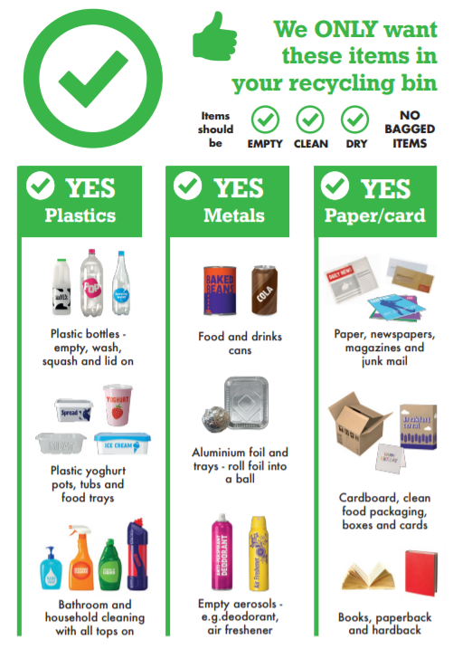
The below items should NOT be placed in your recycling bin as they may contaminate recyclable waste. Some of these items, such as glass and textiles, can be recycled at your nearest Suffolk Recycling Centre or a local bring bank. Cartons, batteries, metal pans and electrical items can all be recycled at your nearest Recycling Centre.
- glass
- food and drink
- textiles (clothes and shoes)
- nappies
- plastic bags and film
- small items under 4cm (shredded paper, loose bottle tops)
- cartons and Tetra-paks
- crisp packets
- pet food pouches
- polystyrene
- gas cylinders
- mobile phones
- batteries
- electrical items
- needles / medical waste
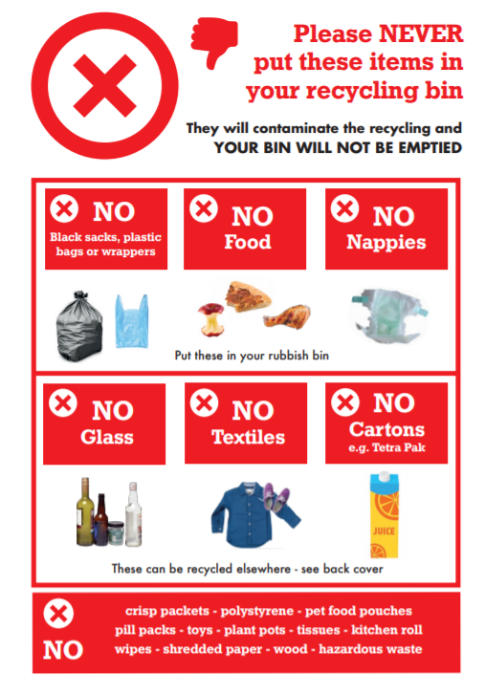
What you can and cannot recycle through your recycling bin.
Find your nearest Recycling Centre and book your time slot. You will only be able to take waste to a Recycling Centre if you have booked a slot.
Find your nearest bring bank (for bottles, clothing and more).
Check which day your bins are collected.
Funding for local communities
The call on my Enabling Communities Budget is as intense as ever and I have donated £7500 already to various projects and pre promised another £2000.
I recently forwarded £400 to Angela Cobbold Hall and at the end of last financial year forwarded £2000 towards the publication of Norman Porter’s new book on the History of Bealings which I hope as many people as possible will purchase!

New beach village gets the go-ahead
As part of ongoing investment, a new beach village is set to be built on Felixstowe’s South Seafront to improve the beach hut experience for locals and visitors. At a meeting of East Suffolk Council’s Planning Committee South today (Tuesday 26 October), approval was given for a new beach village on Felixstowe’s South Seafront.
The beach village will include 5 accessible, purpose-built pods, 27 traditional huts and a new public convenience block with Changing Places facilities. The existing trim trial has been moved to Langer Park and the current volleyball site will be re-landscaped and made into an activity park. As part of this, new outdoor gym equipment will be installed, along with additional facilities, including concrete table tennis tables, a climbing wall, petanque pistes, accessible picnic benches, chess tables and outdoor space for workouts.
The aim of the project is to create accessible facilities that enables families and groups to enjoy everything the beach and town has to offer by hiring a beach pod for a day, or longer, as well as improving facilities for local people and visitors alike with the addition of new public conveniences and an activity park.
Cllr Craig Rivett, East Suffolk’s Deputy Leader and cabinet member for Economic Development said: “Beach huts are an important part of the seaside experience and East Suffolk Council is committed to making this experience more accessible to a wider range of people, allowing families and groups to access and enjoy the beach and resort for a day, or longer. “Tourism is incredibly important to East Suffolk and this new beach village will attract visitors from across the country, increasing footfall in the town centre, boosting the local economy and enhancing the lives of local residents.
“The South Seafront has undergone significant redevelopment in recent years and East Suffolk Council has invested a lot in revitalising the area. We believe it is vital that we continue to build on this investment and create developments that benefits local businesses and people as well as visitors to the area.”
Furthermore, a new name for the site has now been decided after East Suffolk Council ran a recent survey in which local people were asked to vote for their favourite names from a top five. Nearby 500 people took part and with over 30% of the votes, the new site will be named the Seashore Village.
The development is part of a bigger project of ongoing investments in the South Seafront area, where the Martello Park has already delivered new homes, a play area and new car parking facilities. The Council has also invested in the development of a new iconic café, the refurbishment of two public shelters on the South Seafront and the long-term maintenance of its historic Martello Tower. Construction is expected to begin in early 2022 with completion scheduled for later in the year.

Restoring historic character of Lowestoft building
An exciting project to restore the façade of Lowestoft’s former Post Office is set to start later this year.  The project will help improve the condition and appearance of the building whilst restoring its historic character. It will include work to fix the roof, repair the windows, carry out conservation | 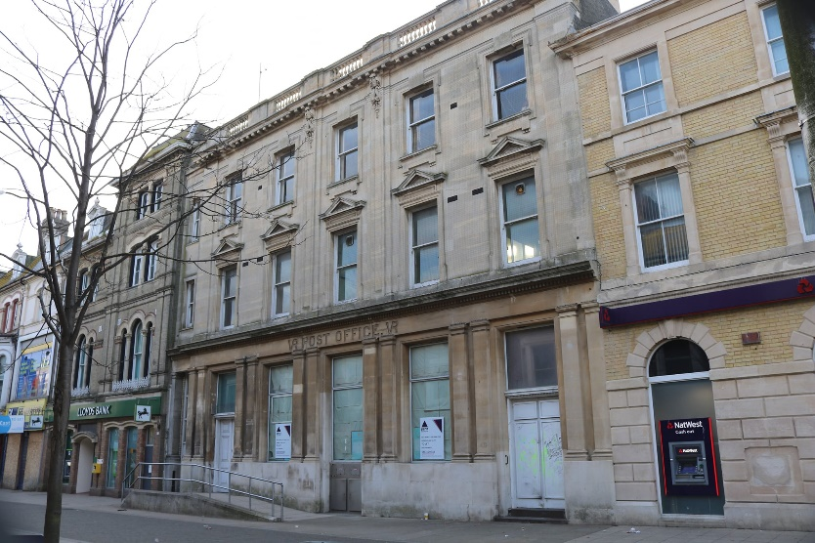
of stonework and reconfigure the ground floor windows to restore the entrance to the central bay of the building, as per the original design of the building. This will incorporate repositioning the existing ramp which would greatly improve the appearance of the building.

A planning and listed building consent application has been submitted on behalf of the Council to seek permission for the scheme and, if approved, work is intended to start in the winter. These repairs will be funded through the London Road, Lowestoft High Street Heritage Action Zone, financed by Historic England and East Suffolk Council, delivered in partnership with Lowestoft Town Council and East Suffolk Building Preservation Trust.

Improving private rented homes in East Suffolk
We're working with Generation Rent UK to better support East Suffolk residents who privately rent their homes and help ensure that homes in the district are secure, safe and energy efficient.

Earlier this year, we asked private renters living in the Harbour & Normanston ward, Beccles & Worlingham ward and Aldeburgh & Leiston wards, to share their experiences in a survey.
Findings from the survey revealed that private renters in these three wards are most concerned about:

- losing their tenancy
- being unable to move into homeownership
- rent increases
- almost 50% of those surveyed are concerned to some degree about being asked to leave their home by their landlord or letting agent this year.

As part of this work, we will be running focus group discussions later this year. Anyone who rents privately in East Suffolk can get involved in these, regardless of which ward they live in. Eligible participants will receive a £10 shopping voucher.

People can sign up now at https://my.eastsuffolk.gov.uk/service/Private_renter_session_registration

Historic shelter reopens following arson attack
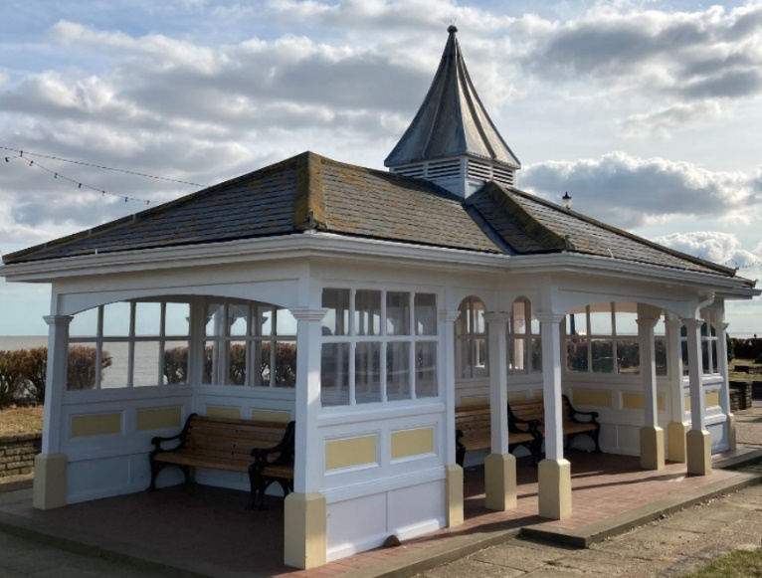 | Having been damaged during an appalling arson attack last year, the historic Manwick shelter on Felixstowe’s South Seafront has been reopened to the community.  The shelter, along with the nearby Arwela shelter, were fully refurbished in 2018 after suffering significant timber decay, vandalism and weather damage over the years, exacerbated by flooding during tidal surges. This £150,000 project was part of the
Council’s ongoing investment in the South Seafront area.

Support available to help businesses recover
Funding and support is available for businesses in East Suffolk which have been, and continue to be, severely affected by Covid-19 restrictions.

Delivered in partnership with the New Anglia Local Enterprise, the new ‘Plan for the Future’ scheme provides support to local businesses which are looking to bring forward investment projects that will have a significant impact on their business. Eligible businesses will be able to apply for grants of between £5,000 and £25,000 to help support their projects.

Businesses wishing to apply for support should first contact the New Anglia Growth Hub on 0300 333 6536 or email growthhub@newangliagrowthhub.co.uk

Expert and impartial Business Growth Advisers will work with businesses to develop an action plan and complete the application.

See more information at www.eastsuffolk.gov.uk/news/support-available-to-help-businesses-recover/

Key infrastructure projects to benefit from £6.3m funding
Over £6 million in contributions from new housing developments has been allocated to support the expansion of schools, leisure and health facilities in East Suffolk.

Earlier this month, cabinet agreed to award a total of £6,308,245 in Community Infrastructure Levy (CIL) funding to support seven major projects which are identified within the Local Plan as being key to planned growth within the local area.

CIL is a fee which we can charge developers when new housing is built in the district. CIL can then be put towards improvements to local infrastructure, such as play areas, schools and GP surgeries. We hold a list of key projects which are included in the Local Plan and these projects are then put forward for the latest round of CIL funding.

See more details about the projects at www.eastsuffolk.gov.uk/news/key-infrastructure-projects-to-benefit-from-6-3m-funding/

Helping young people take the next step
We’re continuing to support young people with further funding agreed by cabinet for the East Suffolk Youth Employment Service (YES), which is helping young people, aged between 16 and 24 years old, to find employment and training opportunities.

Delivered by Inspire Suffolk, young people can visit the dedicated YES. Suffolk website at www.yessuffolk.co.uk to view current job opportunities, find training programmes and other support information and advice. Referrals can also be made by community groups. Young people will be allocated an employment coach to support them into appropriate work, education or training. Wellbeing services are also available, provided by Inspire Suffolk.

Funding agreed to support First Light 2022
To help ensure an incredible programme of activities at First Light Lowestoft in 2022, we've committed £200,000 to support next year's event.

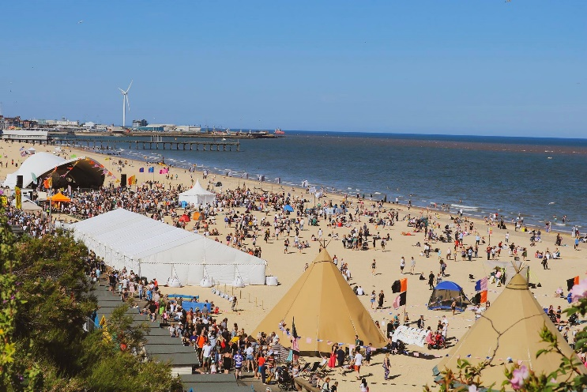 | Plans for the 2022 festival are still being developed but it is hoped that the event will be even larger than 2019, with a focus on young people.  The programme is expected to include a mix of music, international DJs on the main stage, a larger Beach Club Bar, a showcase for talented new musicians and writers, comedy, dance and a late-night silent beach cinema.

Surveys and consultations
We are currently running a couple of surveys and consultations and, as always we want to encourage participation as feedback from people in East Suffolk is invaluable and helps us ensure we’re making the right decisions for our communities.

- Recycling in East Suffolk
As part of a wider social media campaign, we’re currently running a recycling survey to get a better understanding of how much people in East Suffolk know about recycling and what we can do to help when it comes to knowing what items go into what bin. The survey is aimed at social media users only via our online social media accounts and closes tonight.

Staying up to date on the latest East Suffolk news
The Communications Team share all media coverage on Sharepoint, so you can easily stay up to date on all media stories relevant to East Suffolk Council, whether on local, regional or national news outlets, tv, radio, print or online.

Access these at any time at https://eastsuffolkgovuk.sharepoint.com/sites/Communications/Lists/Media%20coverage/AllItems.aspx
If you have any questions or need any help with this service, you can email the team on communications@eastsuffolk.gov.uk

